A Simple Painter Program (JAVA)

Author : Hendra Gunawan （張明曦）
Email : HendraGunawan84@yahoo.com

Location : National Central University of Taiwan

Components:
- Painter.java (Main Program)
- CanvasPanel.java
- ToolButtonPanel.java
- ColorButtonPanel.java
- lineBtn.gif, polygonBtn.gif, ovalBtn.gif, roundRectBtn.gif, squareBtn.gif, freeHandBtn.gif, clearBtn.gif, redoBtn.gif, undoBtn.gif.

Description:
This is a simple Painter program using JAVA language. The program uses 4 classes to build the entire structure.
Please compile using the JAVA SDK, and run the Painter.java as the main program.

Program Ability:
- Draw Line, FreeHand, Oval, Rectangle, Polygon, Round Rectangle,
Filled Oval, Filled Rectangle, Filled Polygon, Filled Round Rectangle
- Undo and Redo process.
- Set Background Color & set Foreground Color.
- Save canvas to file ( *.jpg )
- Open canvas from file
PS: The program will save the canvas into 2 files, (*.jpg) and (*.*)
You must open the (*.*) file in order to edit the picture you saved before.
A Simple Painter Program (JAVA)

Program Structure:

This is the public methods of each class which collaboratively used between classes

- Preview
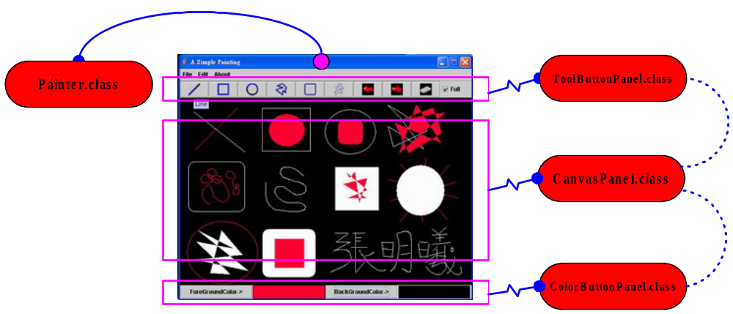

Simple Painter Program

- Main Program

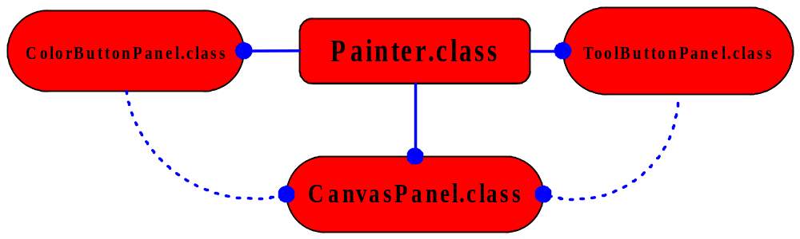
- CanvasPanel.class
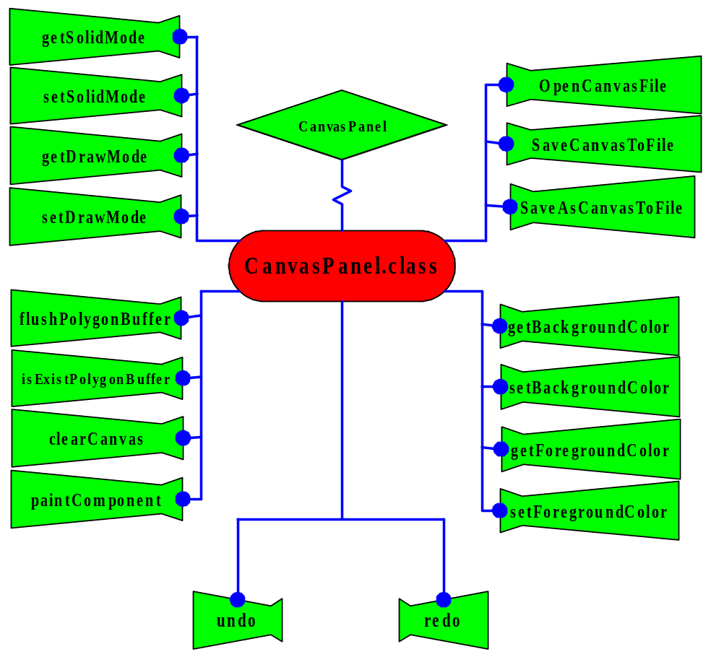
- ToolButtonPanel.class
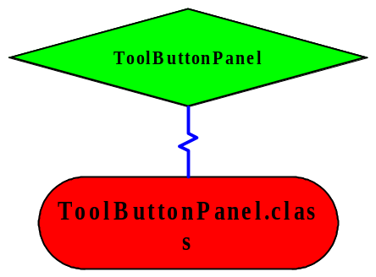

- ColorButtonPanel.class
